Cold War 3 Villians

Great Britian – Malcom Chamberlin (Banking Clan) - Peter Capaldi
A older man, 50's-60's, The Prime Minister of England and owner of the Chamberlin Conglomerate, a global banking business. This man is never nice to any of his co-workers or assistants, he has a foul mouth and often uses it in his business conversations. He always wears a three piece suit and he has a red sport coat, similar to the British colonial dress. If the world wants to get money for their space programs they must have a conversation with Minister Chamberlin.


USSR – Ivan Krevchenko (Arms Dealers) - Til Schweiger
A young man, 30's, the Underboss of the villianous Romonov Crime family based in Moscow. This man is wanted by Interpol for various murders and criminal sales, however he is protected by the Russian government due to the arms contract. He is selected to run the operations of the Russian government on their moon bases, and he rules with an iron fist. Always carries cold war arms, a Black suit, a black shirt and a red tie. When the leader of the crime family dies of old age, he takes over the boss' business, and calls it, Krevchenko Incorporated.
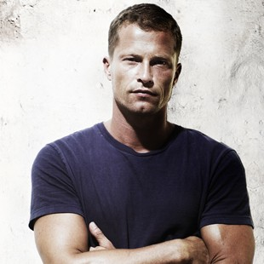

Spain – Anna Torquema' (Metal Mines) - Penélope Cruz
A middle aged woman, 40's, The Prime Minister of Spain and the owner of the maddly successful metal distribution company Torquema' Foundries. He always wears a yellow dresses or yellow pant suits, and has two nasty guards by her side at all times. Their business is bough out by the Russians and this causes Russian guards to inhabit the metal mines in Spain. This causes the two conglomerates and people to butt heads. They hand down their business through their family which causes it to last for years.


France – Louis Duponte' IV (Textiles and Clothing factories) - Joseph Gordon-Levitt
A younger man, mid-20's, metro-sexual, wears blue button down suits with extravagant disigner shoes and pieces. He is fanatical about the way he looks and theirfore dedicated his time to building the largest clothing conglomerate that shares his name. His products come from sweatshop labor in indo-china, and he has a repuation for abusing, both verbally and physically, his assistants. He has “old money” which he never explains where it comes from and always drives extravagant cars to display this mysterious wealth.
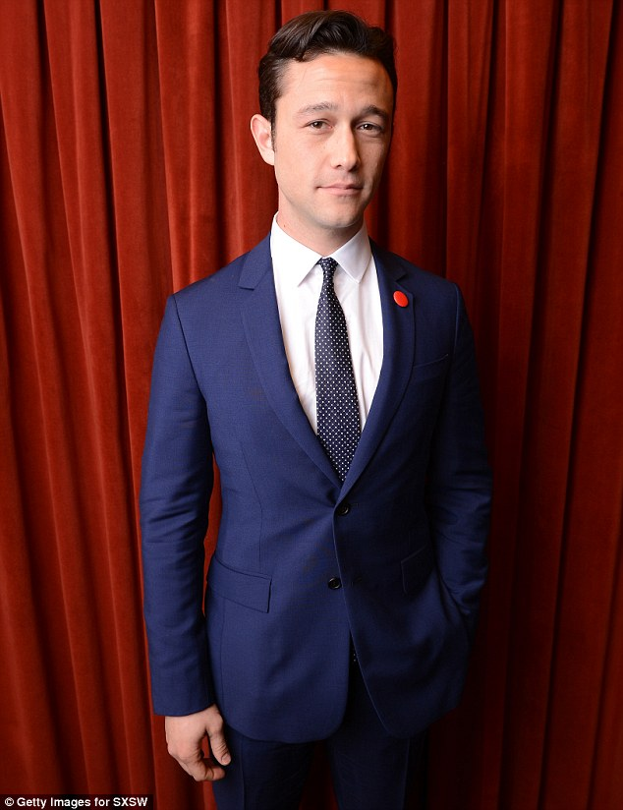

China – Bei Song (Human Trafficking) – Chin Han
Older man, 60's, Former military man, wears his uniform always and this unifor is decorated from his victories against the Nationalists. He uses the wealth he has amassed to create large forces of people for both the military and as slaves, he even has a company that traffics humans called Song Global. He sells people to the other conglomerates to work in the mines in spain and eventually on the moon. He is always ready to make deals that can undercut the other conglomerates and he makes a great deal of money doing this. Always threatens people with military force.
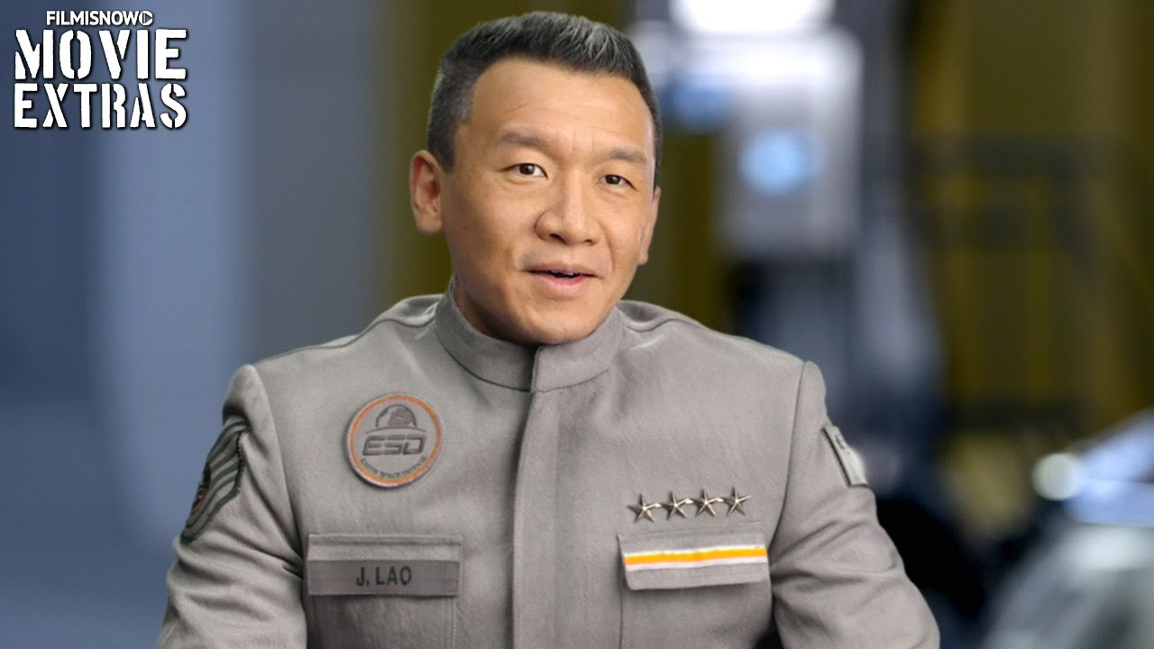

Holland – Otto Van de Burg (Oil Production) – Christoph Waltz

